**Telecom Multi-Agent Chatbot System User guide and maintenance**

**User Guide:**

**Installation\Requirements:**

1. Python v3.9.0 or higher
2. Docker machine
3. Visual Studio Code or any IDE which can run the Python Code.
4. Gemini API Key.

**On Docker Machine:**

1. Once the installation is completed, then `docker pull qdrant/qdrant` on the command prompt. Qdrant is a vector database which stores the embeddings for the efficient retrieval of the data. This is required to generate the response from the RAG model.
2. After qdrant image is pulled, then on the docker machine start the qdrant image by clicking on the play button.

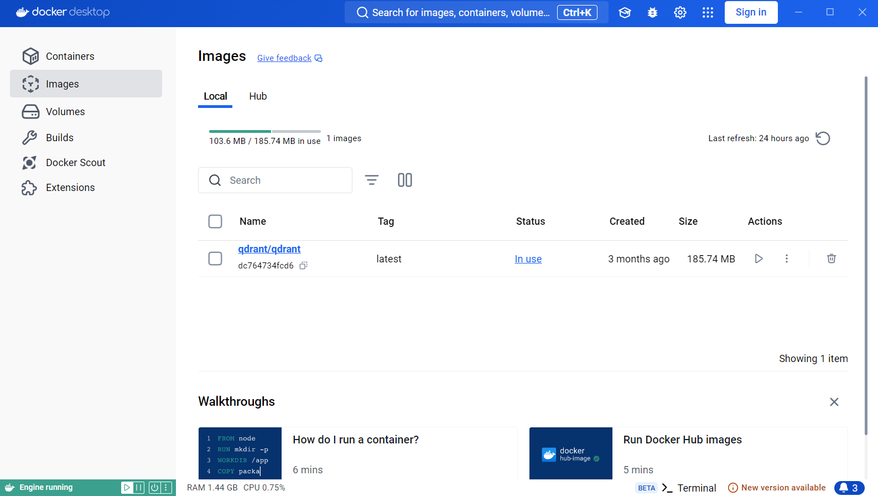

**How to use the telecom multi-agent chatbot system:**

**Note:** To fully utilize the telecom multi-agent chatbot system, we must install all the libraries required to run the system. Some of the python libraries are:

1. Qdrant client for vector database
2. Sentence Transformer for embeddings generation
3. sqlite database to store the excel\csv data
4. langchain\langgraph libraries for multi-agent system
5. Google Gemini for Gemini LLM.

**Steps to get the results:**

1. Run the agent_fm.py file, you’ll be asked for the query which you want.
2. Enter the Gemini API_KEY to Gemini LLM.
3. Enter whatever your query related to either marketing data or technical error or both.
4. Once the query is entered, it will redirect it to specific agent for accurate response of your query.
5. And lastly chatbot will show you the result.
6. You can also ask follow-up questions within 60 seconds of timeframe or you can promptly finish the session by typing ‘Finish’. This will end the session.

**For maintenance:**

You’ll be required to update your:

1. Gemini 1.5 Flash LLM API KEY once in a month (this might require the cost of procuring the API KEY in future).
2. Qdrant docker image
3. Embedding model. Currently we have used BAAI/bge-large-en-v1.5
4. Some of the langchain\langgraph libraries
5. Might have to add additional python files for enhanced system.